# [Introduction to Microsoft PowerPoint Elements](https://support.office.com/en-us/article/Create-your-first-PowerPoint-2013-presentation-42229250-6c66-44cd-adf8-2f5802c63f74?ui=en-US&rs=en-US&ad=US)

**Part 1 – Starting your Presentation**

1. Go to **Start > Programs > Microsoft Office > Microsoft Office PowerPoint 2010**.

2. A ***New Presentation*** will open automatically.

3. Go to **Windows button > Save**. Save your presentation in your **Science** folder. Filename is

***Elementname first initial last name*** (ex. bariumksnow).

4. The PowerPoint window should look like the one below:

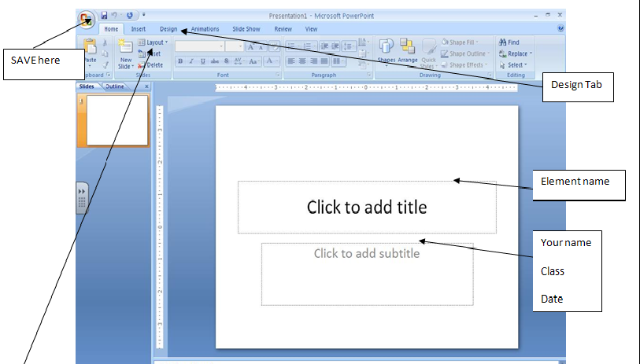

6. In the Task Pane, click the drop down arrow and choose ***“Layout”.*** Click on ***“Title slide”.***

* In **Title** box, add your element’s name.
* 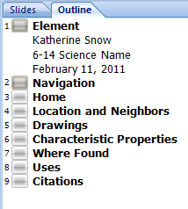In **Subtitle**, add your full name, class & date.

7. Click on the ***“Outline”*** tab in the **Outline Pane** area of PowerPoint. Click to the right of the name of your element. Hit the enter key. A new slide should appear. Type “**Navigation**” next to Slide #2. Hit the Enter key, repeat the process until you have created 9 slides. Use list at right for slide titles. Number #9 is your citations slide.

8. **Save** your work!

**Part 2 – Creating your Navigation Structure**

**1. Slide Design**

Go to the **Menu Bar**, and select the tab labeled **“Design”.** Choose a design for your slides. Make sure ***ALL*** of your slides have ***THE SAME*** theme. Pick a simple one, no bright colors or crazy designs that will take attention away from your information. (Watch video, [click here](https://support.office.com/en-us/article/Apply-and-change-a-theme-de44b332-00db-4424-8957-00c70646e000?ui=en-US&rs=en-US&ad=US) & select “**Play Demo**.”)

**Save** your work!



**2. Navigation**

Click on the **Navigation** slide in the ***Outline Pane***. Create a ***Flow Chart*** of your presentation using **Smart Art.**  (Watch video[, click here](https://support.office.com/en-us/article/Create-a-flow-chart-af4e3f4c-3854-486a-88ff-eb35692663dc?ui=en-US&rs=en-US&ad=US) & select “**Play Demo**.”) You will need 6 boxes.

**3. Add Text** (To change the look of your text, [watch this video!)](https://support.office.com/en-us/article/Highlight-text-and-change-fonts-7b9a9009-b11a-4462-9f13-adc142a2b798?ui=en-US&rs=en-US&ad=US)

Next, you will ***add text*** to your **Shapes**. Click on each shape, a blinking cursor should appear, then type the text for it. Label with name from the slides #3-8. To Change the font, highlight the text in each box, and go to the **home tab** where you can pick a new font, size, or color.

**4. To Change the color of the Smart Art shapes** [Click here for help.](https://support.office.com/en-US/article/Create-a-SmartArt-graphic-FAC94C93-500B-4A0A-97AF-124040594842) Makesure you click on the flow chart first so the design tab will show up.

**5. Add Action Settings**

Click on **Insert> Action**. Choose **Hyperlink to**, then click on **Slide…**You will now see a list of slides, pick the one that matches the words in your *Smart Art* box.

**6. Add “Navigation” Action Button to all your slides**

Got to **View** tab>Click on **Slide Master**. Click on **Insert** tab**>Shapes > Action Buttons.** Now, you will add the , return button or another shape that makes sense to your design. These buttons will bring the viewer back to the previous slide, **Navigation** slide, from an **Information Slide** (Location and Neighbors, Drawing, etc.). Any animation or button added to the **Master** will appear on all slides.

**8. Slide Transitions**

We want our presentations to advance ***only*** when we click on an **Action Button**. While still in the **Slide Master**, select the **Animations** tab. Select an animation. ***Uncheck*** the **On Mouse Click** box. Go back to **View** tab **close** out of **Master** slide. (Watch video, [click here](https://support.office.com/en-us/article/Apply-transitions-between-slides-44c1467e-7bf9-4482-a167-4d60ebebf116?ui=en-US&rs=en-US&ad=US) & select “**Play Demo**.”) 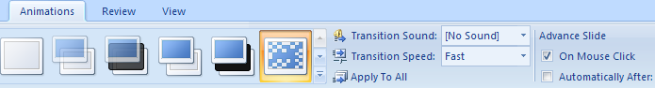

Select Introduction & Navigation slides, change **Advance Slide > On Mouse Click** box.

.

**Part 3 – Adding Text and Graphics to your Presentation**

Now that your Presentation works according to plan, it’s time to add Text and Graphics to your Presentation. We will start with the ***Information Slides*** first. You will create your ***Introduction Slide*** last, since it will be at the end of this assignment that you will be more of an expert on your element. The Key to a good PowerPoint presentation is for the presenter (that’s you) to be knowledgeable and speak to your audience about your element. The PowerPoint should only have short, bulleted bits of information. As a presenter, you will explain each bullet***.*** Your audience should not be reading your PowerPoint, only referring to it as you speak.

***NEVER USE PARAGRAPHS IN A POWERPOINT PRESENTATION, UNLESS YOU WISH TO PUT YOUR AUDIENCE TO SLEEP!***

1. Click on **Location and Neighbors**.

2. Create a ***“Mini table”*** of your element and its neighbors. Go to **Insert tab** then select **Table,** create a table with at least 6 boxes. Label one with the name of your element, then add the surrounding elements. Depending on the location of your element in the chart, it may look different.

|  |  |
| --- | --- |
| Other | Other |
| Other | MINE |
| Other | Other |

|  |  |  |
| --- | --- | --- |
| BLANK | BLANK | MINE |
| Other | Other | Other |
| Other | Other | Other |

**3.** Click on **Characteristic Properties**. Create a **Text Box** and **bulleted** list the **Characteristic Properties** that you found for your element on <http://www.chemicalelements.com./> , you can also use <http://www.webelements.com/> . You must have at least 5. These are suggestions; you may select more, skip or choose different topics and may need to depending on your element:

* Melting Point.
* Boiling Point.
* Structure.
* Conductivity.
* Color.
* Density.
* Classification.

**4**. Click on **Where Found**(Obtained from). [Create a **Bulleted** list.](https://support.office.com/en-us/article/Add-bullets-to-text-db107d33-95c9-4f8a-b79f-ac774f8838a2?ui=en-US&rs=en-US&ad=US) If I was looking for it, where would it be? Underground? In Africa? Contained in other things, like the air? Add a map?

5. Click on **Uses** > **Bulleted** list. Find ***AT LEAST*** one more picture from clip art that shows a use. Write a ***caption*** explaining the picture you just pasted if needed. Cut & paste the name of the source if not clip art on slide #9, this should also include the slide # the graphic is on.

6. Click on **Drawing**. You will create a drawing like the one on <http://www.chemicalelements.com./>.

7. Now, create a ***Drawing*** of your element using **Paint**. [(If you may need help cropping, click here.)](https://support.office.com/en-us/article/Crop-a-picture-to-fit-a-shape-d9ed38c2-1006-4245-9eec-9dd4f722986d?ui=en-US&rs=en-US&ad=US) There is also some addition info needed here: ***Atomic number, mass, number of protons, neutrons, electrons, valence electrons.***

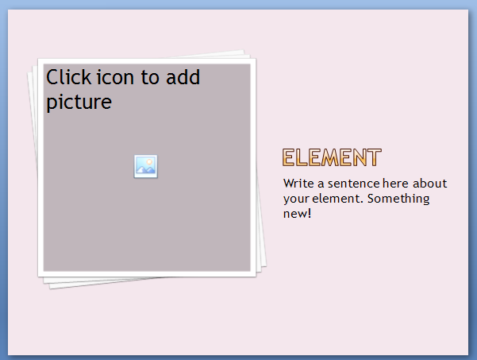8. Click on your **Home slide**. Change the layout to **“Picture w/Caption.”** Choose a picture from one of the Internet sites you used for your research. ***Copy*** the picture and ***paste*** it on your **Home** slide.

9. Write a short ***caption*** explaining the picture you just pasted, this should also include the name of the site below the graphic.

10. Click on your **Home** slide. Add a new text box. Write one interesting fact about your element that you haven’t used elsewhere in your PowerPoint. **Part 4 – Adding** [**EasyBib**](http://www.easybib.com/cite/form/website) **citations to your Presentation**

You have worked hard at researching and creating your PowerPoint presentation. It’s very important to cite the sources of your research. Since you have already created a list of sites you used, it will be very easy to include them in your presentation. We want to do this the right way using EasyBib.

1. Insert a new slide at the end of your presentation; label it “**Citations.”**

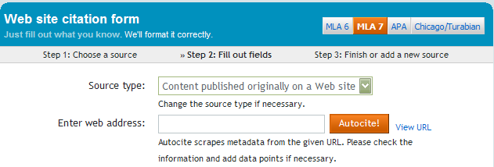2. Open your list of sites then click [EasyBib](http://www.easybib.com/cite/form/website). Need help? [Try this!](http://www.youtube.com/watch?v=8uYhV4OdvkU)

3. Cut and paste site into “Enter web Address:” box. Then click “Autocite!”

4. Scroll down, check gray “Online” box for missing info, box will be outlined in red. You may need to open the site back up in another tab to get the author or dates. These are usually located at the very bottom of any good web page.

5. Cut & paste formal citation onto your last slide.

**Part 5 – Adding Other Actions: Custom Animations and Sounds**

One of the most fun parts of creating a PowerPoint presentation is to add Custom Animations and Sounds.

Here are some guidelines that you ***must*** follow:

1. You must have 10Custom [**Actions**](https://support.office.com/en-us/article/Animate-pictures-clip-art-text-and-other-objects-e7e397b7-ac83-4e4a-9898-4157a948561a?ui=en-US&rs=en-US&ad=US)**,** you already have 6 on your navigation slide, 1 to get back. Are your links in your citations live? That could be 2 or more! Is there a sensible link to a web site you should add? (Periodic table?)
2. ***Bonus: ONLY*** [add sound if it makes sense for your presentation.](https://support.office.com/en-us/article/Add-sound-effects-to-an-animation-7d0e2d70-caca-495e-a738-a8257474605e?ui=en-US&rs=en-US&ad=US) For example, explosions have no relevance to the element lead, since it does not explode. You could add one for Oxygen, Hydrogen or any other flammable/explosive element, but ***ONLY USE ONE SOUND, ONE TIME!*** Got a quiet element? How about some applause at the end of your show?

**Part 6 – Peer Review (if time allows)**

Run your Presentation by clicking **View > Slide Show**, click  or hit the **F5** key on your keyboard. Make sure the navigation works. To quit your show, just hit “Esc.” on your keyboard. Go back to earlier parts of this tutorial if you need to fix something. If you are sure that you have finished, find another student in class who is also finished. Run each other’s presentation. Use the Rubric provided to see that all of the requirements are met. Be sure to also check for:

• Neatness.

• Bullets (Here is some helpful info on grammar for these: <http://www.ossweb.com/article-bullets.html> ).

• [Custom Animations.](https://support.office.com/en-us/article/Animate-pictures-clip-art-text-and-other-objects-e7e397b7-ac83-4e4a-9898-4157a948561a?ui=en-US&rs=en-US&ad=US)

* Grammar check, capital letters on sentences, titles and after bullets.

Remember – you are trying to help each other achieve a high grade. Be constructive in your criticism.

Don’t tell your classmate that everything looks good if you see something that you think he or she will be graded down for. Here are some tips on common mistakes: <http://www.slideshare.net/ham/ten-mistakes-in-powerpoint-presentation> .

**Part 7 – Hand it in!**

Send your presentation via email to Mrs. Snow & your science teacher as an attachment. Make sure the attachment has your name on it!

**6th Grade PowerPoint – Elements**

PowerPoint Presentation Rubric: This is how you get an A!

|  |  |  |
| --- | --- | --- |
| **Science Content** | **Requirements** | **30 Points** |
| Slide #3,  Home | This is a brief definition, introduction or interesting fact for your element & picture. Do not repeat! | 5 points |
| Slide #4  Location & 5 Neighbors | Table: Where it is located on the Periodic Table with the group name. Your element should be most important. | 5 points |
| Slide #5  Drawing | Drawing: your element with labels. Atomic number, mass, number of protons, neutrons, electrons, valence electrons. | 5 points |
| Slide #6  Characteristic properties | Bulleted list: What are the characteristic properties of this element? (solid, liquid, gas @ normal temperatures, reactivity, color, good conductor) | 5 points |
| Slide #7  Where found | Bulleted list: Where can we find this element in nature?  Geology or Biology | 5 points |
| Slide #8  Uses | Bulleted list: What are the uses of this element? | 5 points |
| **Technology** | **Requirements** | 45 Points |
| Slide #1  Title Slide | Name of your element, your Name, Class Number/Class name. | 3 points |
| Slide #2  Navigation Slide | Create a Flow Chart using AutoShapes showing the flow of your presentation. | 10 points |
| Slide master | Selected appropriate background color, font & theme (1 pt each) | 4 points (previously graded) |
| Action Settings | At least 10 action settings (1 pt each)  (Web hyperlinks, slide hyperlinks, sounds, movies) | 10 points |
| Slide transitions | Slide transitions, same on all slides | 3 points |
| Citation slide | Must include sources of information, formatted correctly using Easybib (2 points per slide 3-8) | 10 points |
| Grammar | Correct use of capitals, spelling & punctuation | 5 points |
| BONUS: Pick one | One sound, Only one time OR  Add another slide before citations for history | 1 point |