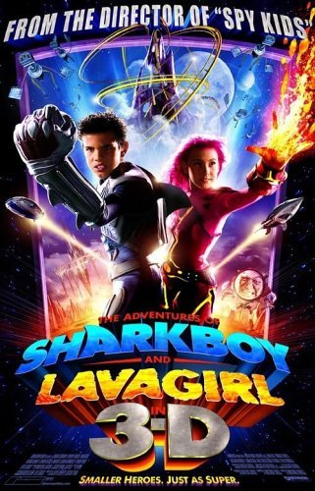**Favorite Movie**

Sharkboy and lavagirl 

Year released 2005

Director Robert rodiguez

Location: planet drool & time period of film :2000

Favorite part: Max is a lonely child who creates a dreamworld named Planet Drool, where all of his imagination and dreams come to life. He creates two characters, with the first one being Sharkboy who was raised by sharks and his dad. The second character is Lavagirl who can produce fire and lava, but has trouble touching objects without setting them alight.

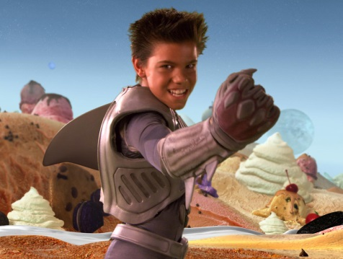

|  |  |  |
| --- | --- | --- |
| Character Name  sharkboy | Actor Name  **Taylor Lautner** | Picture |
| lavagirl | **Taylor Dooley** | Taylor Dooley in The Adventures of Sharkboy and Lavagirl 3-D (2005) |
| Mr electricdad | **George Lopez** | George Lopez, Cayden Boyd, Taylor Lautner, and Taylor Dooley in The Adventures of Sharkboy and Lavagirl 3-D (2005) |
| Max | Cayden Boyd | Cayden Boyd in The Adventures of Sharkboy and Lavagirl 3-D (2005) |

Citations: “The Adventures of Sharkboy and Lavagirl 3-D.” *IMDb*, IMDb.com,Inc / Amazon Affiliates, 10 June 2005, [www.imdb.com/title/tt0424774/?ref_=nv_sr_1](http://www.imdb.com/title/tt0424774/?ref_=nv_sr_1)..