**Create a “Nametag”**

## Getting Started

1. Open **PAINT** (Click your start menu, type in “pa” in search if you don’t see it.)

## STEP 1: Practice Painting

1. **DRAW**: Choose Pencil tool, Brush tool, or Text tool and scribble on the space.
2. **UNDO**: From the toolbar choose ***Edit***, and then choose ***Undo*** from the dropdown list.

## 

Eraser

Pencil Tool

Brush Tool

Text Tool

Fill Color Tool

Shape tool

Line thickness

Fill bucket

Color box

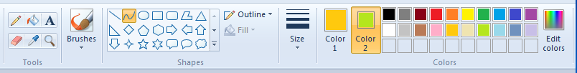

## STEP 2: Write Name

Write name using the one of the three tools.

Name done with airbrush



###### STEP 3: Decorate

1. Choose Pencil tool or Shape tool.
2. Draw image, something you like, around name to decorate nametag.
3. Draw a square or rectangle Fill with Color tool use the Color Box to color & enhance nametag.

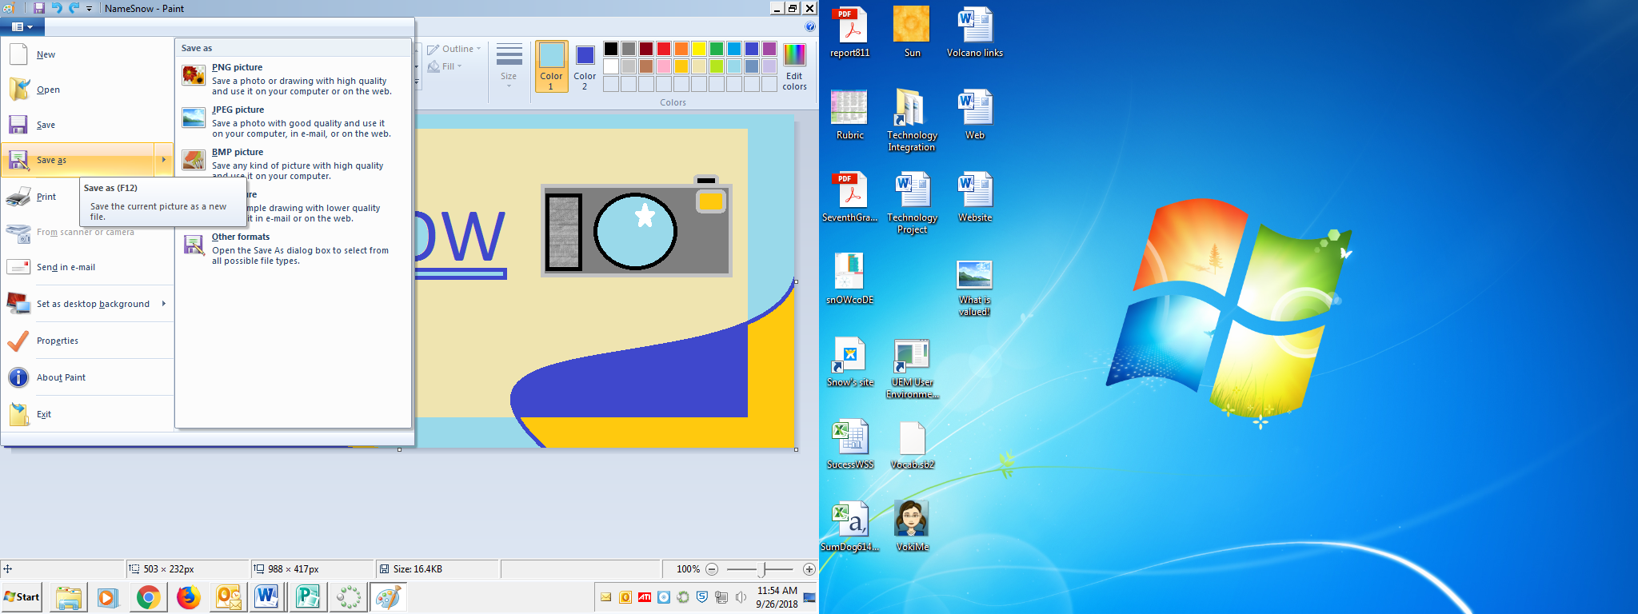

###### STEP 4: Check your work

**How you get a good grade:**

1. Name is clear, important.
2. Box or rectangle with fill color
3. Picture drawn of something you like.
4. Colorful

**STEP 5: Save Nametag**

1. Save nametag to your Pictures Folder with your name.