Trigger Project

[Video,](https://www.youtube.com/watch?v=R89rYpgtWPw) [Other Video](https://www.youtube.com/watch?v=iUHoQR4DnzM), [Online Step-by-Step Help](http://www.indezine.com/products/powerpoint/learn/animationsandtransitions/trigger-animation-ppt2010.html)

Directions: Create a one slide presentation with a partner that uses triggers to launch various objects to an existing picture. Please add the link where you got your picture into your PowerPoint. You can pick from the following or make up a topic of your choice:

* House, realistic or toy
* Dinner or picnic Table
* Ice Cream Cone or Pizza
* Store Front or Business
* Desk w/Computer, etc.
* Dress up an animal

**Coloring pages** of almost anything are available on the web. Make sure you **include a link** to your source.

You need to have **10 items** (The picture shows 5 only. “Red Roof” and the blue square-“RR” count as 1 item) that can be triggered with a way to remove the item. This is on the share, CLICK TO TRY!

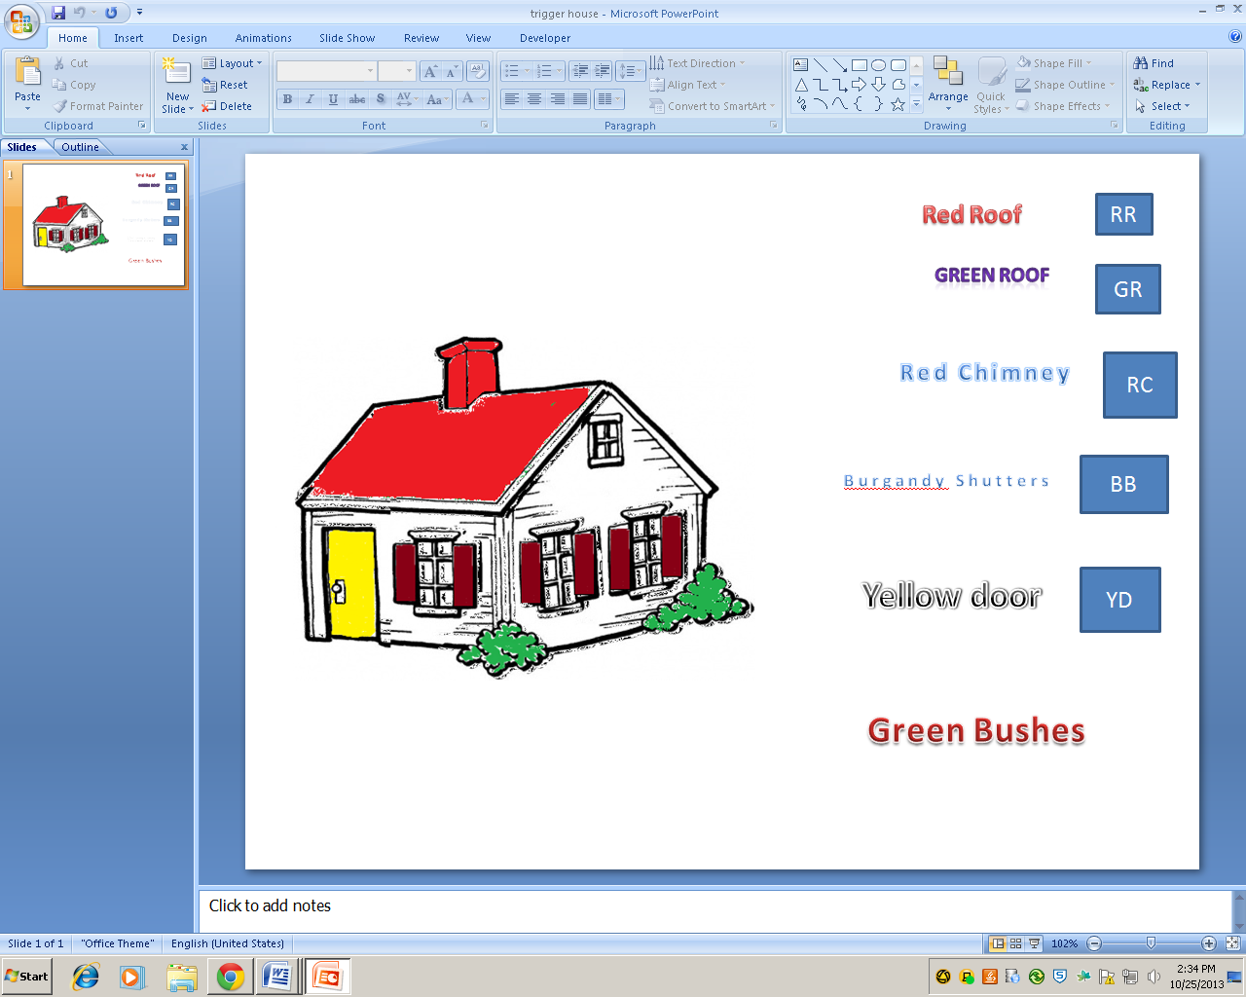

<https://www.123desenhosparacolorir.com/images/house-coloring-pages-2/house-coloring-pages-2.jpg>

Click on the Words “Red Roof” to launch the Red Roof and click the blue rectangle labeled “RR” to remove the red roof. **See next page**

Use the table to track triggers and animations expected. It can get messy if you are not organized. Paste this into the body of the email when you send the project. Also make sure both partners names are in the subject line! 2 points per picture & trigger, 2 for your citation & 3 for appearance.

|  |  |  |
| --- | --- | --- |
| Describe item | What does it do? | What is clicked to make it happen? |
| 1 |  |  |
| 2 |  |  |
| 3 |  |  |
| 4 |  |  |
| 5 |  |  |
| 6 |  |  |
| 7 |  |  |
| 8 |  |  |
| 9 |  |  |
| 10 |  |  |