What’s at Hand?

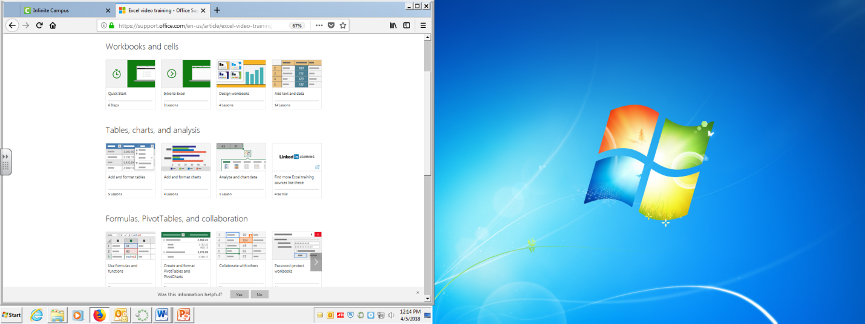

**Take this tutorial:** [**“**Get to know Excel: Create your first workbook”](https://support.office.com/en-us/article/excel-for-windows-training-9bc05390-e94c-46af-a5b3-d7c22f6990bb?wt.mc_id=otc_home&ui=en-US&rs=en-US&ad=US)

Read through the assignment below. Watch top 2 rows.

**HOMEWORK:** Bring in a small bag of items for next class that come in 3-5 colors, shapes or sizes. You will need about 2 small handfuls worth of these items. Look at [the “Excel Activity examples from the past](https://snowkatherine.wixsite.com/techclass/gallery) to get ideas.

**Activity 1: Create an Excel worksheet with data from your handfuls from home**

1. Open a worksheet in Excel. In cell A1, type in an **appropriate title**, ex. "Candy Is Dandy!" if you’re using candy.

2. In row 3, beginning in cell A2, type the following **headings**:

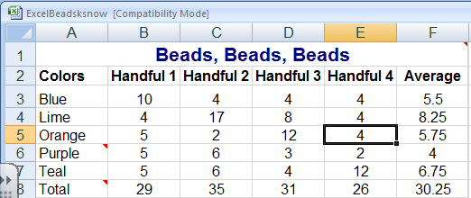

• Colors

• Handful 1

• Handful 2

• Handful 3

• Handful 4

• Average

**Cell notes pop-up box in an Excel spreadsheet**

3. Type in a description of your item as a **comment**. Here's how: Click inside the cell you would like to comment on. Right click then choose “Insert Comment.” Then, type a comment in the yellow pop-up box. Now, any time you move your cursor over that cell, the description will appear. If you do not see a red triangle in the upper right corner of the cell, try again.  [Need more of an explanation, click here.](https://support.office.com/en-US/article/Add-a-comment-BDCC9F5D-38E2-45B4-9A92-0B2B5C7BF6F8)

**Enter Data**

4. In column A, beginning in cell A4, list all of the colors or other identifier of items you found in your handfuls.

5. [**Sort** the list alphabetically](https://support.office.com/en-US/Article/Basic-tasks-in-Excel-2010-be9e91b6-4ecb-4faa-8ae9-37e8974a1f8b#__toc256078354). Here’s how: Highlight the cells in Column A. On the Data tab, choose Sort or click . Type "Total" in the cell below your last entry.



**Activity 2: Adding formulas to your spread sheet**

1. After entering the number of same-colored items in the corresponding cells, you need to add a formula. Use the [**AutoSum** function](https://support.office.com/en-us/article/Use-AutoSum-to-sum-numbers-543941E7-E783-44EF-8317-7D1BB85FE706), , to total your all columns. Highlight the cells you want to add then click the , a new box will be added w/the total.



2. Now you can automatically calculate the average number of each color per bag. Use the same button as above only use the pull down menu . On the menu, choose **Average**.

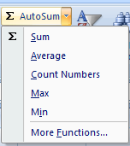

3. In the **Average** column, format cells so that a whole number (that is, no decimal places) is returned by using the [**Decrease Decimal**](https://support.office.com/en-US/Article/Basic-tasks-in-Excel-2010-be9e91b6-4ecb-4faa-8ae9-37e8974a1f8b#__toc256078350) button on the **Number** Box on the **Home** tab.

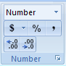

**Activity 3: Creating 2 graphs or charts with your data**

1. Use the **Chart** Box, , on the **Insert** tab to produce two charts. [Creating a chart](https://support.office.com/en-us/article/How-to-create-a-basic-chart-in-Excel-2010-d2267ad9-4abb-4ea5-b1e2-fb094596f118)

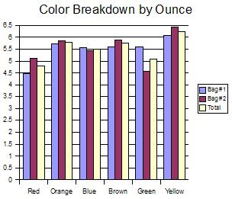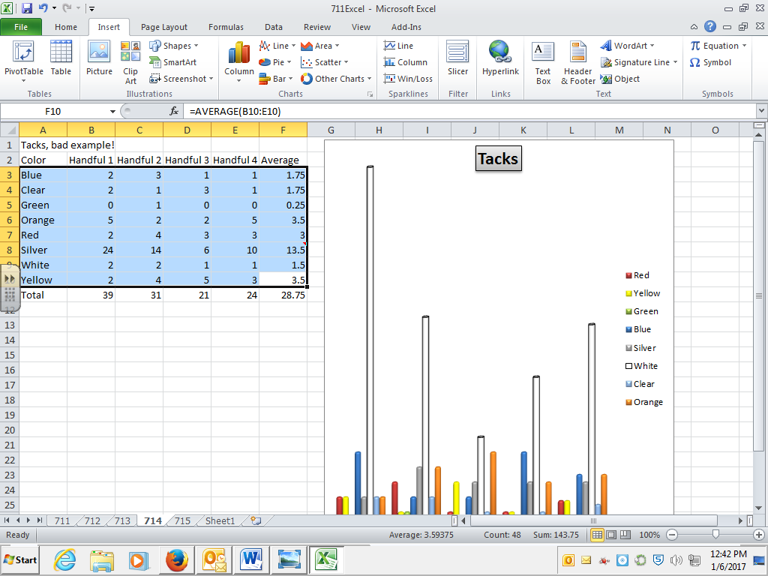

2. Choose the chart type that best represents the data, a bar chart or a column chart. For example, you might choose to chart the distribution of colors in a handful or the total number of item for all handfuls in your sample.

3. Highlight all the cells with information you want on your charts, including headers (*A2:E7 for mine*). On the **Insert** menu go to the **Chart** box. Click the **Column chart** type, and then pick a **2D Column**. A chart should then appear, if parts are missing see below*.

*Click on the chart to open the **Chart Tools**, green tab. On this tab are buttons that allow you to add or edit single areas of your chart in the **Layout**. To add a Title click the button, **Chart Title**. Click the **Legend** tab, choose a location for the legend, if one does not automatically appear.

4. Make sure the chart is placed the chart as an object on the original worksheet you created with the table so the table is visible as you examine the chart. See the below to see what this should look like.

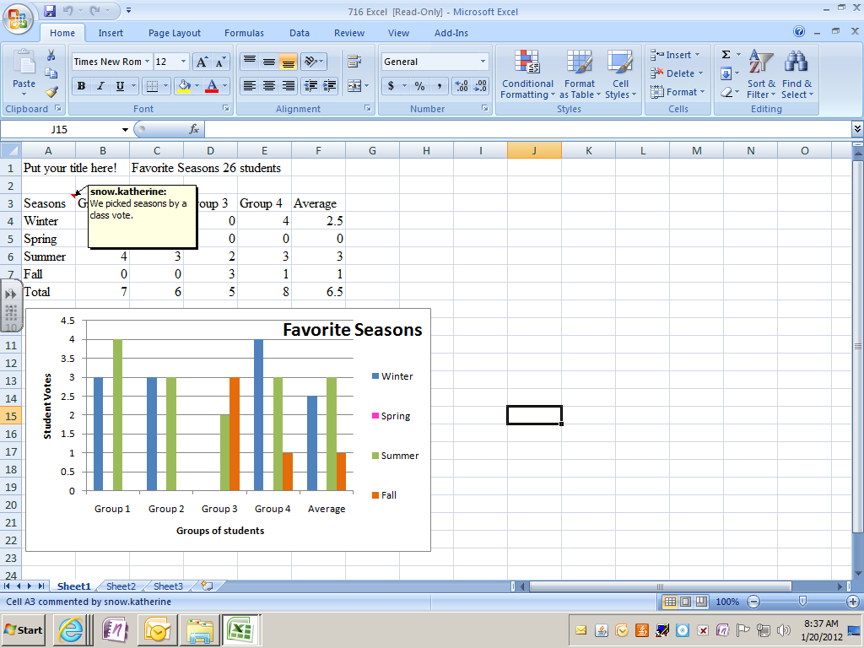

**QUICK CHECK LIST**

__Title is creative and clearly relates to the items being graphed. It’s located at the table’s top.

__Table is well organized (sorted), accurate, and easily read.

__Totals are on table calculated by program, AutoSum.

__Averages are calculated using Auto Average.

__ Inserted a thoughtful and appropriate comment.

__The graph’s title & axis labels clearly describe the units used.

__Key/Legend is clear.

__Both table & graph are included on one sheet, and emailed as an attachment.

__ Document was saved w/a sensible title and your name (last or first initial & last name).

*Send email as high priority, include an appropriate subject.

*Bold & change font color in title, merge cells if needed.

*Add custom shading to your table.

* Create a circle graph or donut graph in addition to the first one.

|  |  |  |  |  |
| --- | --- | --- | --- | --- |
| **Grading Rubric – This is how you earn your grade.** | | | | |
| **CATEGORY** | **4** **Points** | **3** **Points** | **2** **Points** | **1** **Point** |
| **Title** | Title is **creative** and clearly relates to the items being graphed. It’s located at the table’s top. | Title clearly relates to the items and is printed at the top of the table. | A title is present. | A title is not present. |
| **Table** | Table is **well organized (sorted)**, accurate, and easily read. Used AutoSum & average. | Table is accurate, and easy to read. Used one AutoSum or Auto-Average. | Data in the table is accurate and easy to read. AutoSum and average not used. | Data in the table is not accurate, incomplete, messy. AutoSum and Average not used. |
| **Comment** | Inserted a thoughtful and appropriate comment. | Inserted a comment. | Comment contains grammar or spelling error. Not inserted using program, just typed in a box. | No comment. |
| **Graph & Labeling, bar or column** | Title, X axis, Y axis & Key clearly describe the units used. | ¾ items complete. | 2/4 complete. Used shapes to add title. | ¼ complete |
| **Format of email** | Both items are included on one sheet, and saved w/title and your name as attachment. | Both items are included and emailed w/a sensible title as attachment. | Both items are included and emailed as attachment. | Item emailed late or not attached as excel document. |
| **Challenge +2**  **BONUS PTS** | Add custom shading to your table. | Create a circle graph. | Bold & change font color in title only. | Send email as high priority. |

**EXCEL 2010 HELP LINKS**

[Creating a chart](https://support.office.com/en-us/article/How-to-create-a-basic-chart-in-Excel-2010-d2267ad9-4abb-4ea5-b1e2-fb094596f118)

[Make the switch to Excel 2010](http://office.microsoft.com/en-us/outlook-help/redir/XT101905169.aspx?CTT=5&origin=HA101901726)

[Get to know Excel 2010: Create your first spreadsheet](http://office.microsoft.com/en-us/outlook-help/redir/XT102044389.aspx?CTT=5&origin=HA101901726)

[Get to know Excel 2010: Create your first spreadsheet](https://support.office.com/en-us/article/Get-to-know-Excel-2010-Create-your-first-spreadsheet-3323c699-ca68-448e-ab44-12b8e348bbf5)

[Understand data at a glance with conditional formatting](https://support.office.com/en-us/article/Understand-data-at-a-glance-with-conditional-formatting-1e205c9d-8702-4918-9bcb-5da6ff192aa2?ui=en-US&rs=en-US&ad=US)