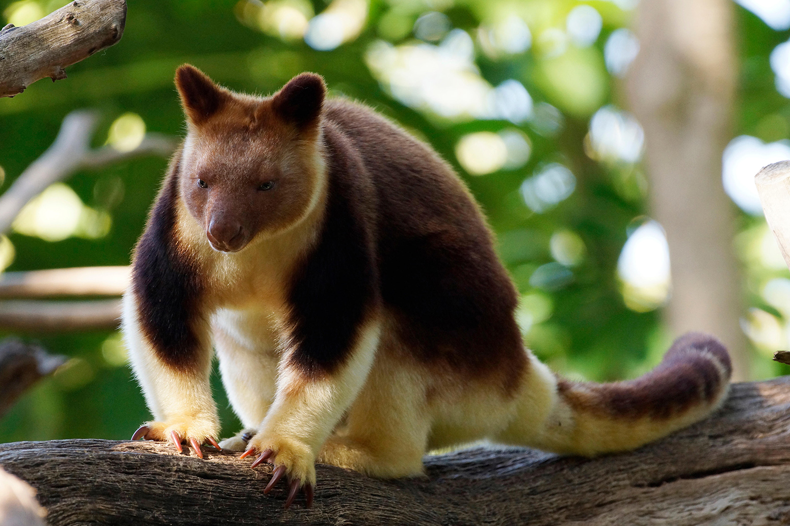
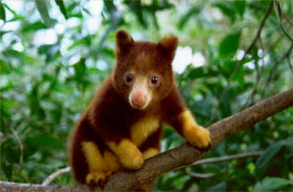
Australia & Pacific Realm Animal Research

My animal: Goodfellow’s Tree Kangaroo

Web site(s): https://perthzoo.wa.gov.au/animal/goodfellows-tree-kangaroo
Goodfellow's Tree Kangaroo.” Western Australian Government, Government of Western Australia, perthzoo.wa.gov.au/animal/goodfellows-tree-kangaroo.
DinoAnimals.com. “Goodfellow's Tree-Kangaroo.” DinoAnimals.com, DinoAnimals, 1 Aug. 2018, dinoanimals.com/animals/goodfellows-tree-kangaroo/.DinoAnimals.com.
“GoodFellows Tree Kangaroo.” Goodfellow's Tree Kangaroo, DMCA, www.listal.com/viewimage/6310601.
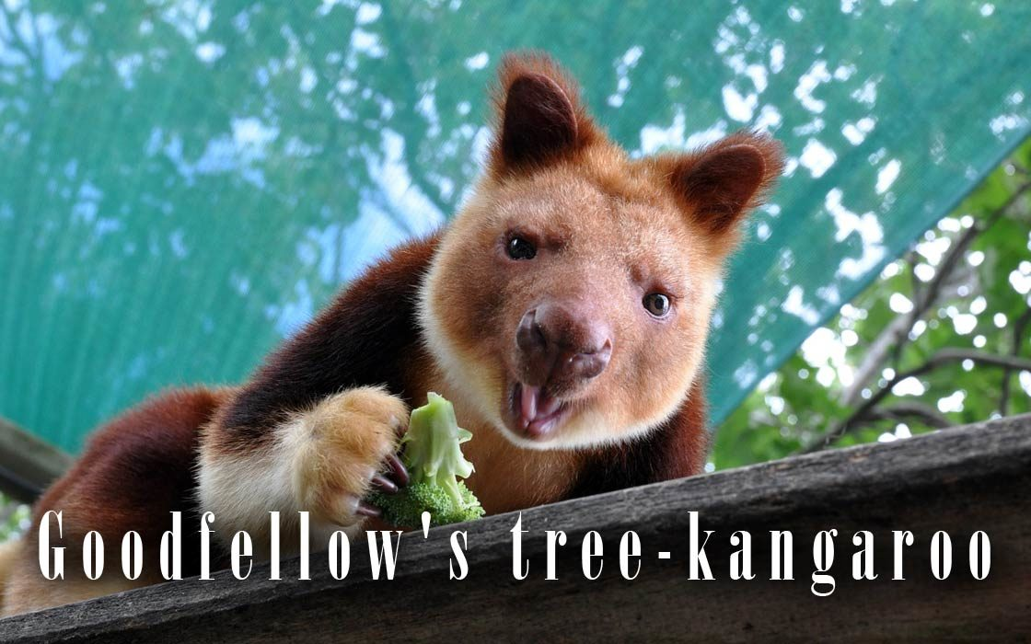

Family, Genus & Species Dendrolagus goodfellowi Macropods Tree-kangaroo

Habitat and location: The GoodFellows Tree kangaroo lives in Oak forests in mountainous areas._Also they are found in rainforests

Statistics (Size, weight & lifespan): _The size of a Goodfellows Tree kangaroo is_5.9–9.5 kg 15-The lifespan of a Goodfellows Tree Kangaroo is 20 years.

Physical adaptations to environment: _The GoodFellows Tree Kangaroo adapts to the environment by climbing trees. Their long tail helps them balance and their strong limbs with rubbery soles help them grip branches

Diet: The GoodFellows Tree Kangaroo’s Diet is mostly of leaves, flowers, fruits, and insects. The also eat eggs and small birds.

Habits: _The Goodfellows Tree Kangaroo’s Habits are climbing trees.

Additional Information: Additional Information for the Goodfellows Tree Kangaroo is That it can leap to the ground from 18 meters up without injury. Also they are mammals and can have about only 1 young. They are endangered.

Highlight your most interesting fact. Email sheet & a picture of your animal to Mrs. Snow.

By Bella Orrall

