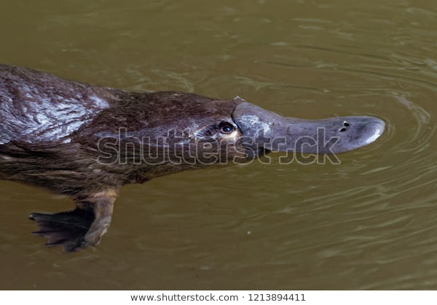
Australia & Pacific Realm Animal Research
My animal: Platypus
Web site(s) Pelanek, Martin. “Platypus - Ornithorhynchus Anatinus, Duck-Billed Platypus, Semiaquatic Egg-Laying Mammal Endemic to Eastern Australia, Including Tasmania.” Platypus Ornithorhynchus Anatinus Duckbilled Platypus Semiaquatic Stock Photo (Edit Now) 1213894411, © 2003-2019 Shutterstock, Inc., www.shutterstock.com/image-photo/platypus-ornithorhynchus-anatinus-duckbilled-semiaquatic-egglaying-1213894411. Carnemolla, John. “Tasmania , Platypus Eating Worm.” Tasmania Platypus Eating Worm Stock Photo (Edit Now) 615165578, © 2003-2019 Shutterstock, Inc., www.shutterstock.com/image-photo/tasmania-platypus-eating-worm-615165578 Sartore, Joel. “Platypus.” National Geographic, Copyright © 2015-2019 National Geographic Partners, LLC. All Rights Reserved, 21 Sept. 2018, www.nationalgeographic.com/animals/mammals/p/platypus/
Family And Genus: Ornithorhynchus anatinus
Habitat and location Platypuses live in Australia in river environments because they mostly hunt underwater.
Statistics (Size, weight & lifespan): Platypuses weigh 3 pounds, live 17 years, and are 15 inches not counting their tail, and 20 inches counting the tail.
Physical adaptations to environment: Platypuses hunt underwater with electric currents to guide them. Platypuses are one of the two mammals who lay eggs. Platypuses have venom glands on the heels of their feet with stingers to inflict the poison.
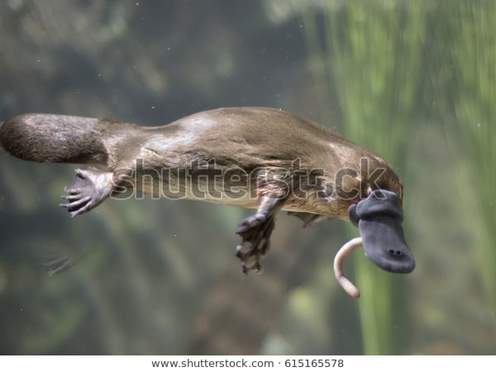
Diet Platypuses eat insects and their larvae, shellfish, and worms
Habits: Platypuses hunt underwater with electric currents to guide them “Platypuses use their nails and feet to construct dirt burrows at the water's edge.” Additional Information Platypus infants are the size of lima beans and are totally helpless at hatching. They are raised 3-4 months until they can swim on their own.
