**Your Weight and Age on Other Planets**

*Source: National Aeronautics and Space Administration (NASA)*

Discover how much you, your pet or something sensible weighs and how old it is in other parts of the solar system. Make 2 comments predicting where it will be the oldest and where it will be the lightest. To investigate your hypothesis, make an organized table to find out how much you weigh on other planets using the [Solar System Data Table](http://btc.montana.edu/ceres/html/Weight/weightsolardata.htm) to see which planets have properties that might affect your weight on other planets. You will need to calculate the weight and ages.  You will need to make a comparison chart, a line graph works well.

**To find what you would weigh** in the gravitational field of another planet, multiply your weight on Earth times the gravitation factor listed in the table below. If you are unsure of your weight, use your friend’s, dog’s, cat’s or make one up.

Example: I weigh 90 pounds on Earth.

On Mercury, I would weigh: 90 pounds*gravitational pull value from chart = ??? pounds

On Neptune, I would weigh: 90 pounds* gravitational pull value from chart = ??? pounds

Which planetary property seems to cause you to weigh more or less on other planets?

**To find your age** according to the length of another planet's year, divide your age in Earth years by the period of revolution (in Earth years) of the planet listed in the table below.

Example: I am 13 Earth years old.

In Mercury's orbit, I would be: 13 years /revolution value from chart = ?? years old

In Neptune's orbit, I would be: 13 years/revolution value from chart = ?? years old

[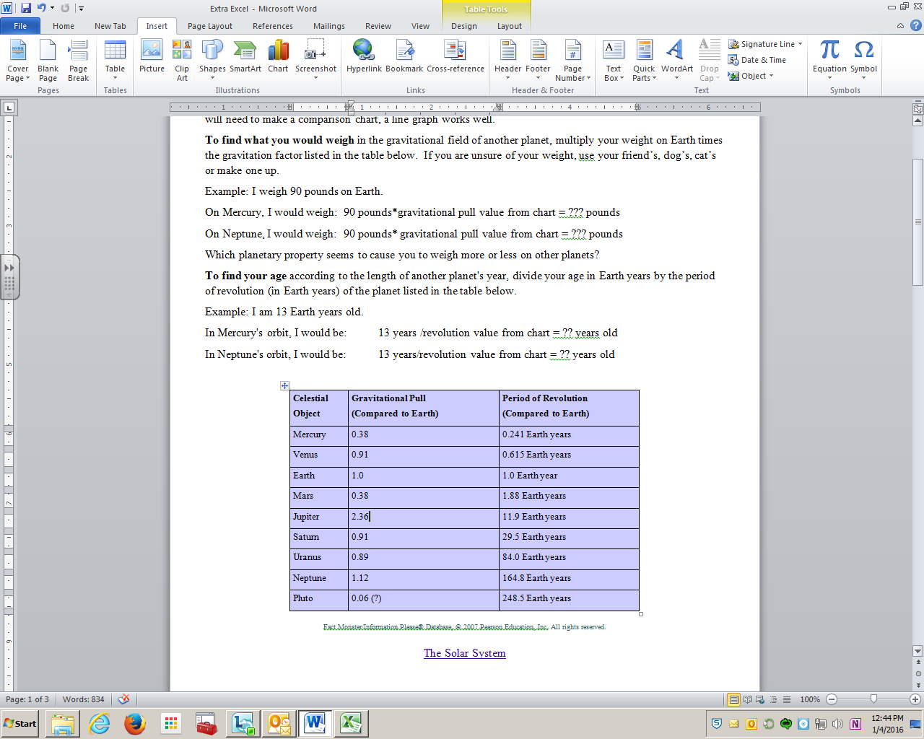](http://btc.montana.edu/ceres/html/Weight/weightsolardata.htm)

Click picture for table data or link above.

[The Solar System](http://www.factmonster.com/ipka/A0909527.html) – additional info

**Enter a formula that contains references (Ex. =A1+23)**

The following formulas contain relative references (relative reference: In a formula, the address of a cell based on the relative position of the cell that contains the formula and the cell referred to. If you copy the formula, the reference automatically adjusts. A relative reference takes the form A1.) to and names (name: A word or string of characters that represents a cell, range of cells, formula, or constant value. Use easy-to-understand names, such as Products, to refer to hard to understand ranges, such as Sales!C20:C30.) of other cells. The cell that contains the formula is known as a *dependent cell*, its value depends on the values in other cells. For example, cell C1 is a dependent cell if it contains the formula =C3.

|  |  |
| --- | --- |
| **Example formula** | **What it does** |
| =C3 | Uses the value in the cell C3 |
| =C3/4  =B3*C3 | Divides C2 by 4  Multiplies cell B3 by C3 |

1. 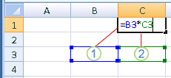Click the cell where you want to enter the formula. In the formula bar (formula bar: A bar at the top of the Excel window that you use to enter or edit values or formulas in cells or charts. Displays the constant value or formula stored in the active cell.) Formula bar, type **=** (equal sign).
2. Create a reference, select (click on) the cell you want to multiply or divide. If there are letters or words this will not work. They will need to be deleted. Then type in the rest of the math equation you want to perform.
3. Press ENTER.

Helpful links**:** [Tutorials link here!](http://office.microsoft.com/en-us/excel-help/how-to-create-a-basic-chart-in-excel-2010-RZ102559017.aspx?CTT=1) [**Comments** here.](https://support.office.com/en-US/article/Add-a-comment-BDCC9F5D-38E2-45B4-9A92-0B2B5C7BF6F8) [**Sort** the list alphabetically](https://support.office.com/en-US/Article/Basic-tasks-in-Excel-2010-be9e91b6-4ecb-4faa-8ae9-37e8974a1f8b#__toc256078354)

**GRADING** (See Rubric on following page for detail, there is also a graphic to refer to below.)

**QUICK CHECK LIST**

__Title is colored, merged and centered; it clearly relates to the items being graphed.

__The title is located at the table’s top.

__Table is well organized, sorted, easily read.

__ Spelling is correct.

__Weights are on table calculated by program; I can click and see the math.

__ Ages are on table calculated by program; I can click and see the math.

__The graph’s title & axis labels clearly describe the units used, a line graph works well.

__ The graph’s Key/Legend is clear.

__ Added custom shading and color to your table and title.

__ Both table & graph are emailed as an attachment; the document was saved w/a sensible title and your name.

|  |  |  |  |  |
| --- | --- | --- | --- | --- |
| **Grading Rubric: This is how you earn your grade. /24 total points** | | | | |
| **CATEGORY** | **4** **Points** | **3** **Points** | **2** **Points** | **1** **Point** |
| **Title** | Title clearly relates to the items being graphed. It’s located at the table’s top. | Title is spelled incorrectly. | A title is oddly placed. | A title is not present. |
| **Table** | Table is well organized **(sorted),** accurate, and easily read. Percentages and AutoSum calculated by program. | Table is organized, accurate, and easy to read. Percentages or AutoSum calculated by program. | Data in the table is accurate and easy to read. AutoSum not used or percentages are calculated by student. | Data in the table is not accurate, messy. AutoSum not used and percentages are not calculated. |
| **Comment** | Inserted two predictions as comments. | Comments contain grammaror spelling errors. | One comment or not inserted using program, just typed in a box. | No comment. |
| **Graph/chart & labeling** | The title, axis labels & key are clear. **Age & weight displayed.** | 3/4 items completed. | 2/4 completed. | Graph does not function at all, but exists. |
| **Customize color & appearance** | Bold & change font color in title, merge cells to center above table. Add custom shading to your table. | 3/4 items completed. | 2/4 completed. | 1/4 completed |
| **Format of email** | Both items are included on one sheet, and saved w/title and your name as attachment. | Both items are included and emailed w/sensible title as attachment. | Both items are included and emailed as attachment. | Item emailed late or not attached as excel document. |

