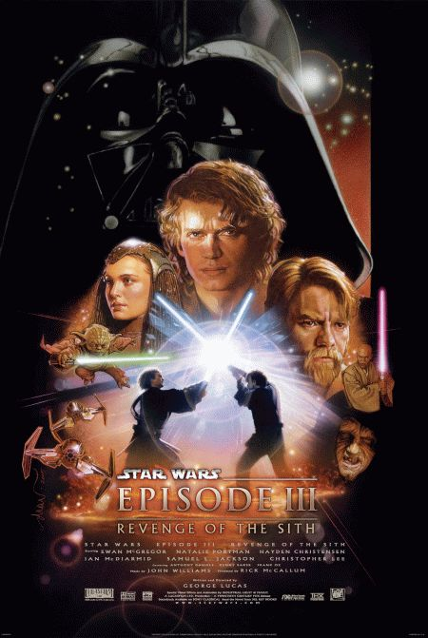**Favorite Movie**

Title: The Revenge of The Sith, Star Wars Episode III

Year released: 2005

Director: George Lucasa

Writer if based on book: George Lucasa

Location & time period of film: a long time ago, in a galaxy far, far away

* Summary
* After a few years of fighting Count Dooku and his army of droids. They finely rescued Palpatine. Obi-Wan Kenobi is fighting General Grievous an creep show with four arms. Yoda sences a desurbence in the force and thinks something very bad is going to happen…

|  |  |  |
| --- | --- | --- |
| Character Name | Actor Name | Picture |
| Anakin Skywalker | Hayden Christensen | Hayden Christensen in Star Wars: Episode III - Revenge of the Sith (2005) |
| Obi-Wan Kenobi | Ewan McGregor | Ewan McGregor and Jimmy Smits in Star Wars: Episode III - Revenge of the Sith (2005) |
| Padme | Natalia Portman | Natalie Portman in Star Wars: Episode III - Revenge of the Sith (2005) |
| Master Yoda | Frank Oz | Frank Oz in Star Wars: Episode III - Revenge of the Sith (2005) |

Citations- “Star Wars: Episode III - Revenge of the Sith.” *IMDb*, IMDb.com,Inc / Amazon Affiliates, 17 May 2005, [www.imdb.com/title/tt0121766/?ref_=nv_sr_1](http://www.imdb.com/title/tt0121766/?ref_=nv_sr_1) .