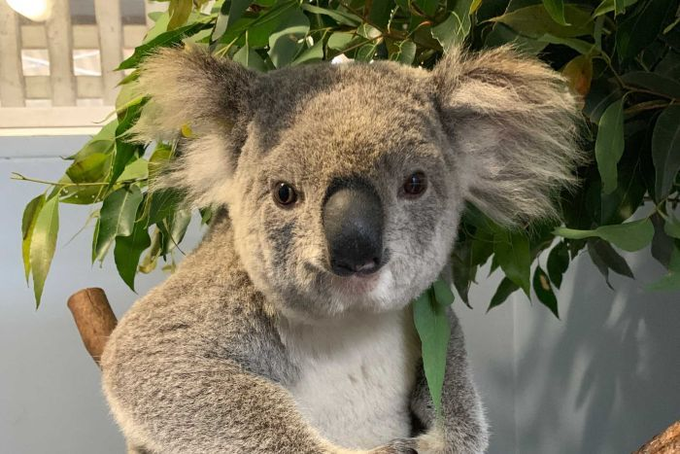
Australia & Pacific Realm Animal - Research
-----------------------------------------------------------------------------------------------------------------------------------
Name: Shelby Rabinovitz
My animal: Koala
Web site(s):
Maps, National Geographic. “Koala.” Kids' Games, Animals, Photos, Stories, and More, 14 June 2019, kids.nationalgeographic.com/animals/mammals/koala/ .
Family, Genus & Species: Koala, Mammal, Phascolarctos ← GENUS
Habitat and location: Australia, forests or coastal islands.
Statistics (Size, weight & lifespan): Lifespan: 20 years, Size: 23.5 to 33.5, Weight: 20 pounds.
Physical adaptations to environment: Climbing on trees, finding food for them-selves, finding places to live.
Diet: Herbivore
Habits: Koalas sleep during daytime, Koalas eat leaves at night-time.
Additional Information: Koalas get water from leaves,
Highlight your most interesting fact. Email sheet & a picture of your animal to Mrs. Snow.
