**A Children’s Book**

You are going to write and illustrate an original and creative children’s book!

Before you start writing you will need to visit Storybird.com and look at the artwork available. You can search a term, like “dog,” then click “Artwork” to see pictures by theme. There are also “Categories” on the bottom left of <http://storybird.com/> to scan. See bottom for cartoon website options.

When you have chosen an artist, you then need to create a simple (6 section minimum) **story map first**. Use Inspiration,* a program on the network or [remote server](https://apps.whrsd.org/RDWeb/Pages/en-US/default.aspx), [overview here](http://www.youtube.com/watch?v=cOj6V3ub_1s), Prezi, SmartArt (flowcharts) in Word or Google Apps: Draw.io [(See examples?)](https://drive.google.com/open?id=0B40VZxehDa5BU3RBT3BNcDVBUWs) or “LucidChart for Education,” a diagram maker add-on for Google Docs. DO NOT USE PAINT OR JUST SHAPES IN WORD. Remember, I am [Katherine.Snow@whrsd.org](mailto:Katherine.Snow@whrsd.org) to share on Google.

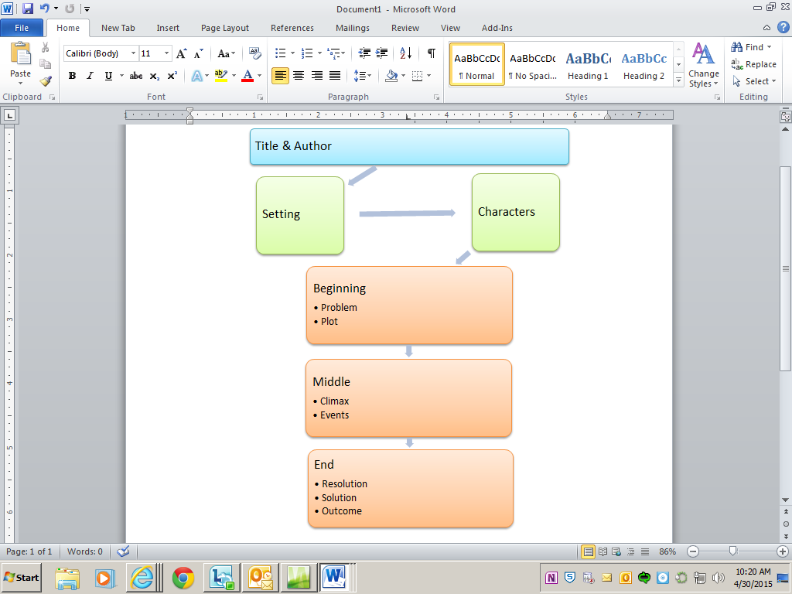1 - Story Map simplest graphic allowed using SmartArt

You can view more examples of story maps at the following links (**Do not copy graphics** from sites below!):

<http://www.eduplace.com/rdg/gen_act/pigs/story_mp.html>, <http://www.eduplace.com/graphicorganizer/pdf/storymap1_eng.pdf>, <http://www.eduplace.com/graphicorganizer/pdf/storymap2_eng.pdf>, <http://www.enchantedlearning.com/graphicorganizers/storymap/>.

Think simple; story should be 10-20 pages!

**If working with a partner, both students must send their own map.**

Your story will consist of **10 or 20 pages** with fitting/sensible **pictures**. On each page you will write at least **two** grammatically correct **sentences**.

You will be using storybird.com to create your children’s book online. I have accounts on Storybird for you or you can create your own.

1. Cover – title, illustration, author’s name

2. On each page of the story be sure you have two sentences and use a font that is easy to read. You should have an illustration for each page displaying your character(s), the place and/or a clear idea of what the character(s) is going to do.

|  |  |  |  |  |
| --- | --- | --- | --- | --- |
| **Two sentences per page** | **Excellent – Full points** | **Good – Slight deduction** | **Partial/Incomplete** | **None/Missing – No credit** |
| **Pre-writing – 10 pts.** This will be graded separately. | 10 pts. – Easy to read, well organized; it is obvious where the story is headed. | 8 pts. - Readable, organized; clear ideas where the story is headed. Missed a required section. | 5 pts. - Not well organized; major gaps exist. Incorrect format or program, just used shapes. | **3 pts. Created, turned in after story was written.**  0 pts. - Not submitted. |
| **Time on Task -5 pts.** | 5 pts. - Used class time efficiently and effectively to complete book on time. | 4 pts. - Handed in previous to next class, worked from home, or chatting in place of working. | 2 pts. - Handed in late or disruptive behavior preventing others from success. | None/Missing |
| **Title Page – 5 pts.** | 5 pts. - Includes name, title & illustration | 4 pts. – Includes 2/3 | 2 pts. – Includes 1/3 | None/Missing |
| **Illustrations – 10 pts.** | 10 pts. – 10 pages w/illustrations that match text | 8 pts. - 7-9 pages w/illustrations that match text | 5 pts. – 4-6 pages w/illustrations that match text | 3-0 pts. – 1 point per page |
| **Writing – 10 pts.** | 10 pts. – 10 pages w/2 sentences each | 8 pts. - 7-9 pages w/2 sentences each | 5 pts. - 4-6 pages w/2 sentences each | 3-0 pts. – 1 point per page |
| **Creativity –**  **10 pts.** | 10 pts. – Story is interesting, original & descriptive. | 8 pts. - Story is original, but not very interesting or descriptive. | 5 pts. – This sounds like something I’ve heard before. | 2 pts. – I can name the story you stole. |
| **Grammar & Spelling – 10 pts.** | 10 pts. – Less than 3 errors | 8 pts. - Less than 6 errors | 5 pts. - Less than 10 errors | 2 pts. – Grammar is a mess or story is largely incomplete. 0 pts. – I can’t understand this. |
| **Spanish Grammar & Spelling – 10 pts.** | 10 pts. – Less than 3 errors | 8 pts. - Less than 6 errors | 5 pts. - Less than 10 errors | 2 pts. – Grammar is a mess or story is largely incomplete. 0 pts. – I can’t understand this. |

**Quick check list:**

1. Cover includes name or names, not exact is good.
2. Cover includes title.
3. Cover includes illustration.
4. Story has 10 pages or 20 if working with a partner.
5. All pages have illustrations that make sense with text.
6. All pages have 2 sentences each.
7. Your story is interesting.
8. Your story is original.
9. Your story is descriptive.
10. Your grammar is good, you used spell or grammar check.

|  |  |  |  |  |
| --- | --- | --- | --- | --- |
| **Partner work** | **Excellent – Full points** | **Good – Slight deduction** | **Partial/Incomplete** | **None/Missing – No credit** |
| **Pre-writing –**  **10 pts.**  This will be graded separately. | 10 pts. – Easy to read, well organized; it is obvious where the story is headed. | 8 pts. - Readable, organized; clear ideas where the story is headed. | 5 pts. - Not well organized; major gaps exist. Incorrect format or program. | 3 pts. Created after story was written. 0 pts. - Not submitted. |
| **Time on Task -**  **5 pts.** | 5 pts. - Used class time efficiently and effectively to complete book on time. | 4 pts. - Handed in previous to next class, worked from home, or chatting in place of working. | 2 pts. - Handed in late or disruptive behavior preventing others from success. | None/Missing |
| **Title Page –**  **5 pts.** | 5 pts. - Includes both names, title & illustration | 4 pts. – Includes 2/3 | 2 pts. – Includes 1/3 | None/Missing |
| **Illustrations –**  **10 pts.** | 10 pts. – 20 pages w/illustrations that match text | 8 pts. - More than 15 pages w/illustrations that match text | 5 pts. – More than 10 pages w/ illustrations that match text | 3-0 pts. – 1 point per page |
| **Writing –**  **10 pts.** | 10 pts. – 20 pages w/2 sentences each | 8 pts. More than 15 pages w/2 sentences each | 5 pts. - More than 10 pages w/ 2 sentences each | 3-0 pts. – 1 point per 2 pages |
| **Creativity –**  **10 pts.** | 10 pts. – Story is interesting, original & descriptive. | 8 pts. - Story is original, but not very interesting or descriptive. | 5 pts. – This sounds like something I’ve heard before. | 2 pts. – I can name the story you stole. |
| **Grammar & Spelling –**  **10 pts.** | 10 pts. – Less than 5 errors | 8 pts. - Less than 10 errors | 5 pts. - Less than 15 errors | 2 pts. – Grammar is a mess or story is largely incomplete. 0 pts. – I can’t understand this. |
| **Spanish Grammar & Spelling –**  **10 pts.** | 10 pts. – Less than 5 errors | 8 pts. - Less than 10 errors | 5 pts. - Less than 15 errors | 2 pts. – Grammar is a mess or story is largely incomplete. 0 pts. – I can’t understand this. |

[Pixton](http://www.pixton.com/for-fun) - This is the comic strip creation website for artists. The site allows for as much customization as possible without the need to build from scratch. Instead of just choosing the color of a character's shirt, there are options to adjust the collar, shape, sleeves and size of the shirt. Instead of relying on preset poses and emotions for each character, users are able to click and drag character limbs into new postures and can customize eyes, ears, noses and hairstyles. It's also allows [Google](http://mashable.com/category/google/) images. There is a 30 day free trial available on Edmodo.

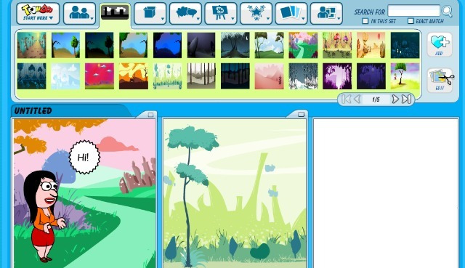[ToonDoo](http://www.toondoo.com/)

ToonDoo only allows 4 boxes, but you cand create 3 and screen shot together. While there's still an extensive library of characters and objects to use in your comic strip, there are also tools to create your own touches. The TraitR tool allows you to create custom characters and DoodlR lets you paint freely. If you want to use your own photos or another image in your comic strip, you can manipulate it through the ImagineR photo tool.T**here's an option to save your project mid-creation so that you can come back to it later**.

[Strip Generator](http://stripgenerator.com/strip/create/) - The stoic characters of Strip Generators lend themselves to sarcastic commentary. There's not a whole lot of opportunity to create a personal style — you need to work with what the site gives you — but that doesn't mean you can't be creative. One unique capability is adjustable frames. If you need a specific cell to be a bit wider or longer, you can just drag the wall. Another stand-out trait is the personal library. When you tweak an image to get it just right, you can save it to use again later.

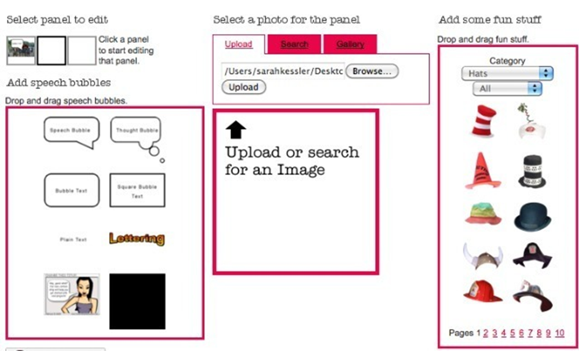[Pikistrips](http://www.pikistrips.com/user/login)

Pikistrips takes your photos (er..."Pikis?") and turns them into comic strips. Once you upload your favorites into a customizable comic cell format, you're free to add text bubbles, speech bubbles and objects. Many of the categories — like hairstyles, hats, mustaches, scars, and tattoos — wouldn't be much fun without using your own photos as a canvas. If you miss the cartoon look, you can apply the "comic" effect to your photo.

All in all, this site is fun for tweaking your photos, but is intended to boost the company's custom printing.