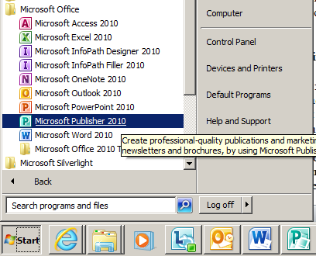
Postcards in Microsoft Publisher
Instructions: You will create a unique Postcard that can be sent via email to friends and family. Topics may include Birthdays, Halloween, Thanksgiving, Veteran’s Day, Thank you, Thinking of you, etc.
Getting started:
- Open Microsoft Publisher (Start>Programs>Microsoft Office>Publisher)
- The Available Templates will open automatically. They can also be accessed by clicking New in the menu tab.
- Click on Postcards.
- You can choose from the many pre-formatted cards available in Publisher by double clicking the card of your choice. The best ones are the Holidays in the All Marketing folder. If you wish to change the format later, you can use the Change Template button on the Page Design Tab.
- These cards already include graphics and wording by category. You will need to change these to make your card unique. So, you may not complete a Christmas card on a Christmas card template, try a Thanksgiving card on a Christmas template.

The Insert Tab contains Building Blocks, they are reusable pieces of content that are stored in galleries. These are new to you will allow you to create a professional looking Postcard, please take a minute to review these.
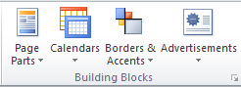
The gallery contains:
- Page Parts: This gallery is for pre-formatted structural elements for your publication such as headings, sidebars, and stories.
- Calendars: This gallery is for pre-formatted monthly calendars. You can select the current or next month from the gallery, or select the month and year from the gallery from the Building Block Library.
- Borders & Accents: This gallery is for graphic elements such for adding borders, emphasis, and frames.
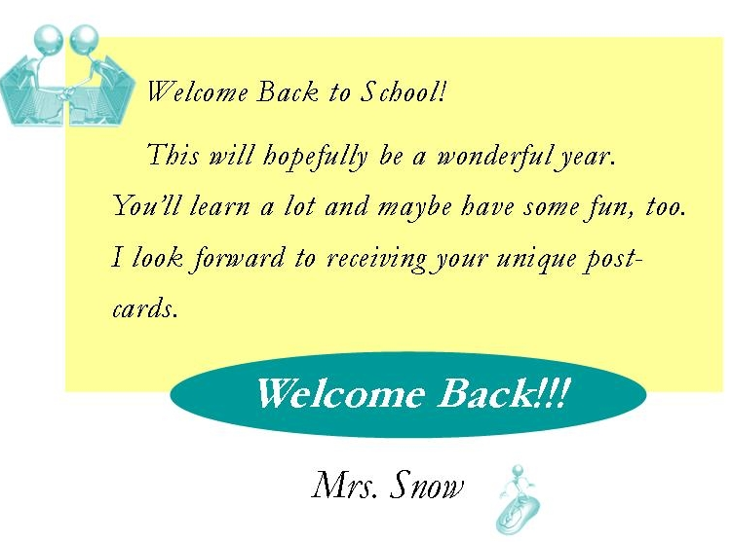
- Advertisements: This gallery is for pre-formatted advertisement elements, including coupons.

This is an example of the front of a Postcard. You can select pictures from the clipart gallery, or create your own with the tools described below. Your greeting can be as creative as you want it to be. Don’t forget to write a message on the back.

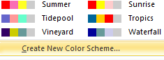
- Once you have found the template, design you like, you should change the color theme. Chose the Page Design tab to see a list of color themes you can apply to your card. Think about the PowerPoint on color and the discussions we’ve had about color theory. You make changes to the themes if needed by pulling the color menu down and clicking Create New Color Scheme.
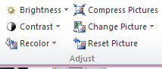
- All graphics must be changed. On some cards graphics are grouped and may need to be ungrouped in the Picture tab before editing. The Adjust box has several tools that are helpful with this and is on the Picture tab as well. You may Insert ClipArt, WordArt, Shapes or Pictures by clicking on the appropriate buttons, too! Be careful, try to limit the number of pictures or groups to 3 or 5, don’t let your card get cluttered.
- When you have finished your card, check the rubric (next page), then have a classmate recheck the grammar. Remember !!! is not correct English grammar, noticed it is underlined in green here.
Postcard Assessment Rubric – This is how you will earn your grade.
Category | Yes 2 pts | Partially 1 pt –  ONLY one page | No 0 pts | Points earned
Graphics were changed | All graphics were changed | Some graphics were changed. | No changes
Unique message for card | Contains unique message | Common, message could be found elsewhere. | No changes
Color scheme changed | All new colors. | Font color changed, but not full scheme. | No changes
Mechanics | Spelling and grammar are correct throughout. | Spelling and grammar were checked, but contains 1-2 errors. | Contains 3 or more errors.
Visual Presentation | Visually striking; attention apparent to making postcard personal and unique. | Clear, uncluttered, and attractive. Think in groups of 3 or 5, refer to the color PPT if needed. | Messy
Emailed | Sent to Mrs. Snow & another in body of one email, both pages cropped neatly. | Just sent to Mrs. Snow as an attachment or not cropped. | Not emailed or received late.
Total points | On time | Late - 1 pt over a week. | Late -2 pts over two weeks. | Total ___ /12
- Email a copy to Mrs. Snow & the intended recipient of the card. Send it with both pages in the body of the email, not as an attachment.

