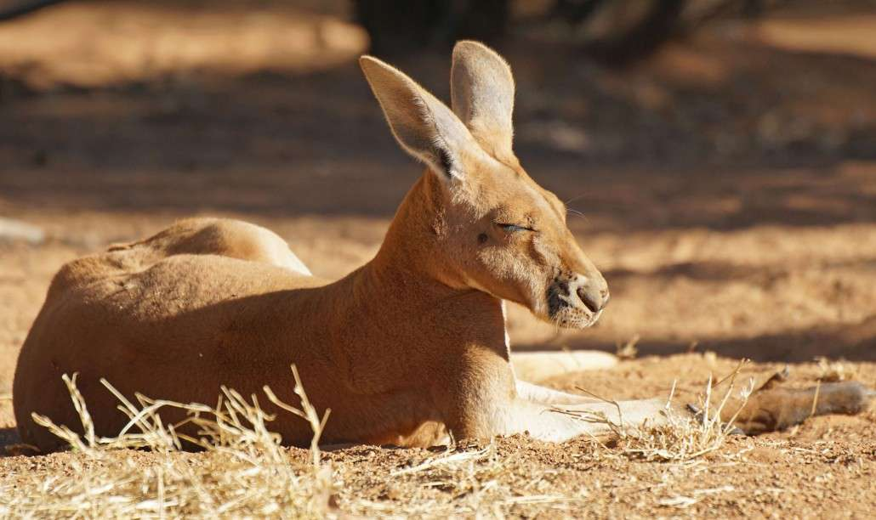 *Australia & Pacific Realm Animal Research*

**My animal:** Red kangaroo

**Web site(s):”**   
Rufus, Microbus. “Red Kangaroo Habitat, Diet & Reproduction - Reptile Park.” *Australian Reptile Park - Wildlife Park Sydney & Animal Encounters Australia*, 22 May 2017, reptilepark.com.au/animals/mammals/red-kangaroo/.

rufus, Macropus. “Red Kangaroo Habitat, Diet & Reproduction - Reptile Park.” *Australian Reptile Park - Wildlife Park Sydney & Animal Encounters Australia*, 22 May 2017, reptilepark.com.au/animals/mammals/red-kangaroo/.<https://animalcorner.co.uk/animals/red-kangaroo/> <https://en.wikipedia.org/wiki/Red_kangaroo>”

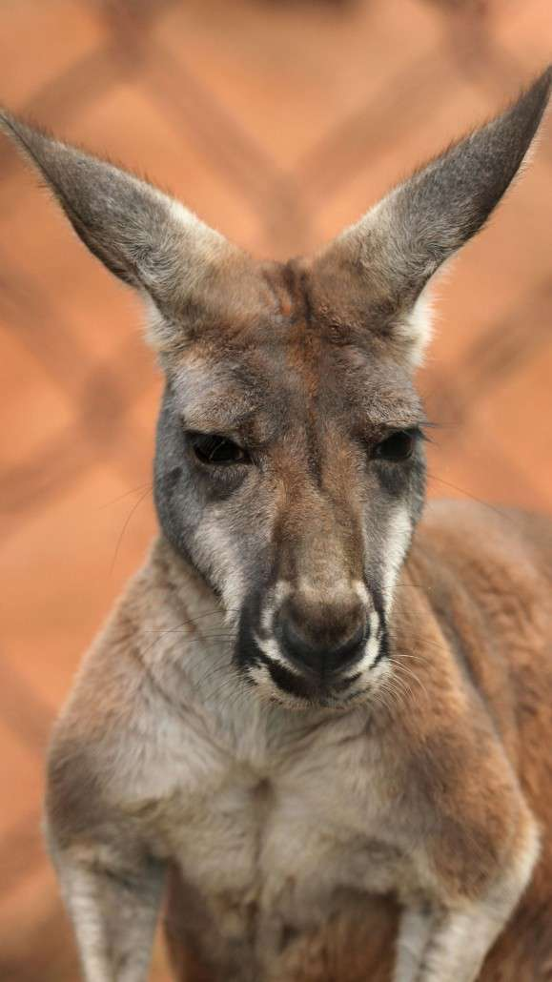

**Family, Genus & Species: Genus=**[Macropus](https://www.google.com/search?safe=active&rlz=1C1GCEB_enUS873US873&q=Macropus&stick=H4sIAAAAAAAAAONgVuLUz9U3SK6yTMl4xOjMLfDyxz1hKatJa05eYzTh4grOyC93zSvJLKkUUuNig7JkuHilELo0GKS4uRBcnkWsHL6JyUX5BaXFAAiSB7heAAAA) , Species= Macropus rufus

**Habitat and location: “**The **red kangaroo** ranges throughout western and central Australia. Its range encompasses scrubland, grassland, and desert **habitats**. It typically inhabits open **habitats** with some trees for shade. **Red kangaroos** are capable of conserving enough water and selecting enough fresh vegetation to survive in an arid environment.”

**Statistics: Size, weight and lifespan red kangaroo can like up to 22 years. The red kangaroos weight is about 62 to 63 lbs**

**.**

**Physical adaptations to environment: “Kangaroos** need very little water to survive. The intestine of the **Red Kangaroo** reabsorbs water as it passes through. This recycling process makes good use out of the little water they have available. **Kangaroos** have very large tendons in their hind legs that stretch easily.”

**Diet: A Red kangaroo mostly grasses, shrubs, and most green plans and can go long periods of time without water.**

**Habits:** grazing on grasses but also eat forbs and leaves of shrubs.

**Additional Information**: Red kangaroos have short forelimbs with small claws. Their hind limbs are long and muscular, and used for jumping. Some jumps can travel up to 16 feet in one leap. Red kangaroos have strong tails that are sometimes used to create a tripod when standing upright.

**Highlight your most interesting fact. Email sheet & a picture of your animal to Mrs. Snow.**