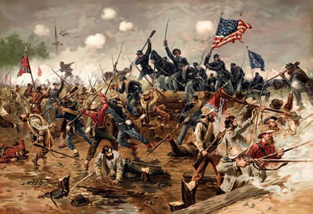 The American Revolution 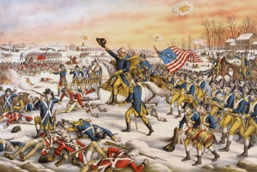

|  |  |  |
| --- | --- | --- |
| A | American Revolution | The American Revolution war was to free the 13 colonies from great Brittan. In the Revolutionary War the Patriots (the colonists that want to have independents from great Britain) and the loyalists (the colonists that stayed loyal to great Brittan) faced each other. |
| **B** | Boston Massacre | On February, 22 a mob of patriots attracted a loyalists store and a solder tried to break it up by shooting his gun through a window but shot an 11 year old instead. After a couple days a huge fight broke out. |
| C | Continental Congress | The continental Congress served as the colonists Government each one of the 13 colonies had a representative to speak for them at the Continental congress. |
| D | Declaration of Independence | The Declaration of independents was written for King George the 111 and was declaring the colonists freedom. |
| **E** | England | England was the home of the colonist before they came over to the united states. |
|  | February 26, 1775 | For the first tome the colonist stood up to the British. |
| G | George Washington | George Washington was the commander and chief of the continental army during the American Revolution and after George Washington defeated the British he became president. |
| **H** | Alexander Hamilton | Alexander Hamilton died in a duel ageist Aaron Burr. |
| I | Intolerable Acts | The Intolerable acts were punishment for the Boston tea party. |
| J | July 8, 1775 | John Dickinson wrought the olive branch potion witch was used by the Second Continental Congress and summited to King George the 111. |
| **K** | King’s Mountain | The King Mountain Battle was a military agreement were the patriots had a huge win by defeating the British. |
| L | Lexington | The first battle of the American Revolution was at Lexington and Concord. |
| M | Minutemen | ≠Militiamen who volunteered to be ready for service at a minute's notice. |
| **N** | Naval Warfare | Naval warfare is war or a battle on sea or large bodies of water. |
| O | Olive Branch Petition | The Olive Branch petition was trying to avoid war but asking King George the 111 to take back all the taxes and let the colonists have more freedom, once the petition reached King George he refused to read it. |
| P | Parliament | Parliament is the members of parliament for a particular period, especially between one dissolution and the next. |
| **Q** | Battle of Quebec | This battle was a big loss for the Americans. |
| R | Paul Revere | Paul Revere was captured on the ride to Concord to worn John Hancock and Samuel Adams that the British are coming. |
| S | Samuel Adams | Samuel Adams Signed the Decoration of Independence. |
| **T** | Townshend Acts | The Townshend act taxe**s o**nimports of paper, paint, lead, glass, and tea. |
| U | United States of America | America is 241 years old, it has been 241 years since the Declaration of Independents was approved. |
| **V** | Yorktown | The Battle of Yorktown Cornwallis surrendered to George Washington |
| W | George Washington | George Washington was the commander and chief of the Continental Army. |
| **X** | Taxation without Representation | The English Parliament controlled the taxes and the colonists didn’t have any one to represent them. |
| Y  Y | Yankee Doodle | Yankee Doodle dandy was to make fun of Cornwallis for surrendering. |
| Z | Peter Zenger | Peter Zenger was a New York writer. |

Citations:

“What Is the Song Yankee Doodle Dandy’ Really about?".” *What Is the Song Yankee Doodle Dandy" Really about?"*, [www.cliffsnotes.com/cliffsnotes/subjects/history/what-is-the-song-yankee-doodle-dandy-really-about](http://www.cliffsnotes.com/cliffsnotes/subjects/history/what-is-the-song-yankee-doodle-dandy-really-about)