|  |  |  |  |  |
| --- | --- | --- | --- | --- |
| **Grading Rubric: This is how you earn your grade. /24 total points** | | | | |
| **CATEGORY** | **4** **Points** | **3** **Points** | **2** **Points** | **1** **Point** |
| **Title** | Title is creative and clearly relates to the items being graphed. It’s located at the table’s top. | Title is the same as question on EdModo, not creative. | A title is present**,** but **spelled** **incorrectly** or oddly placed. | A title is not present. |
| **Table** | Table is **well organized/** **sorted,** accurate, and easily read. Percentages and AutoSum calculated by program. | Table is organized, accurate, and easy to read. Percentages or AutoSum calculated by program. | Data in the table is accurate. AutoSum not used and percentages are calculated by student. | Data in the table is not accurate, messy. AutoSum not used and percentages are not calculated. |
| **Comment** | Inserted a thoughtful and appropriate comment. (Tell me your favorite?) | Inserted a comment. | Comment contains **grammar or spelling errors**. Not inserted using program, just typed in a box. | No comment. |
| **Graph/chart, bar or column, & labeling** | The title & labels (x & y axis) clearly describe the units used, key is clear. | 2/3 items complete. | 1/3 complete | Graph does not function at all, but exists. |
| **Format of email**  Non-returning must note, not in class last year. | Both items are included on one sheet. Saved w/title and your **name** as attachment. | Both items are included and emailed w/sensible title as attachment. | Both items are included and emailed as attachment. | Item emailed late or not attached as excel document. |
| **Returning Students MUST COMPLETE ALL FOUR (1 point each)** | Add custom shading to your table. | Create a circle graph or donut graph in addition to the first one. | Bold & change font color in title, merge cells if needed. | Send email as high importance or priority, include an appropriate subject. |

EXCEL RUBRIC

**Help Excel 2010**

**[GRADE 7 Directions Sheet](S:\\Hanson Middle\\Technology Integration\\7th Snow\\Excel Lesson.docx)**

Formula Help is on the next page.

[Creating a chart](https://support.office.com/en-us/article/How-to-create-a-basic-chart-in-Excel-2010-d2267ad9-4abb-4ea5-b1e2-fb094596f118)

[**“**Get to know Excel: Create your first workbook”](https://support.office.com/en-us/article/How-to-create-a-basic-chart-in-Excel-2010-d2267ad9-4abb-4ea5-b1e2-fb094596f118)

Understand data at a glance with conditional formatting

[Start & Intro to Excel](https://support.office.com/en-us/article/excel-for-windows-training-9bc05390-e94c-46af-a5b3-d7c22f6990bb?wt.mc_id=otc_home&ui=en-US&rs=en-US&ad=US)

[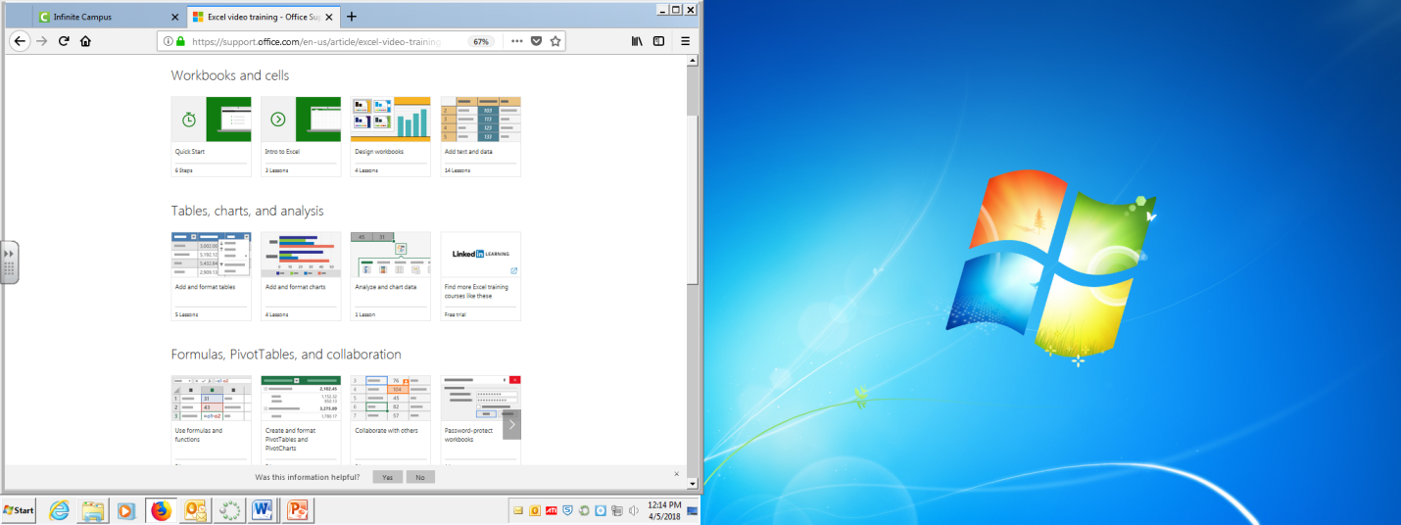](https://support.office.com/en-us/article/excel-video-training-9bc05390-e94c-46af-a5b3-d7c22f6990bb?wt.mc_id=otc_home&ui=en-US&rs=en-US&ad=US)

**FORMULA HELP**

[Get to know Excel 2010: Create formulas](http://office.microsoft.com/en-us/outlook-help/redir/XT102044397.aspx?CTT=5&origin=HA101901726)

**Enter a formula that contains references Ex. =A1+23**

The following formulas contain relative references (relative reference: In a formula, the address of a cell based on the relative position of the cell that contains the formula and the cell referred to. If you copy the formula, the reference automatically adjusts. A relative reference takes the form A1.) to and names (name: A word or string of characters that represents a cell, range of cells, formula, or constant value. Use easy-to-understand names, such as Products, to refer to hard to understand ranges, such as Sales!C20:C30.) of other cells. The cell that contains the formula is known as a *dependent cell*, its value depends on the values in other cells. For example, cell B2 is a dependent cell if it contains the formula =C2.

|  |  |
| --- | --- |
| **Example formula** | **What it does** |
| =C2 | Uses the value in the cell C2 |
| =C2-4  =C2*6 | Subtracts 4 from the cell C2  Multiplies cell C2 by 6 |

1. 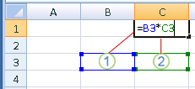Click the cell where you want to enter the formula. In the formula bar (formula bar: A bar at the top of the Excel window that you use to enter or edit values or formulas in cells or charts. Displays the constant value or formula stored in the active cell.) Formula bar, type **=** (equal sign).
2. Create a reference, select (click on) the cell you want to multiply or divide. If there are letters or words this will not work. They will need to be deleted. Then type in the rest of the math equation you want to perform.
3. Press ENTER.
4. This equation can then be dragged down the column if it applies.

**QUICK CHECK LIST**

__Title is creative and clearly relates to the items being graphed. It’s located at the table’s top.

__Bold & change font color in title, merge cells if needed.*

__Table is well organized **(sorted),** accurate, and easily read.

__ Percents are on table calculated by program. AutoSum is used.

__ Add custom shading to your table.*

__ Inserted a thoughtful and appropriate comment.

__The bar graph’s title & axis labels clearly describe the units used, key/legend is clear.

__ Create a circle graph or donut graph in addition to the first one.*

__Both table & graph are included on one sheet, and emailed as an attachment.

__ Document was saved w/a sensible title and your name (first initial & last name).

__Send email as high priority, !, include an appropriate subject.*

*Starred items may be skipped if not in tech last year.

