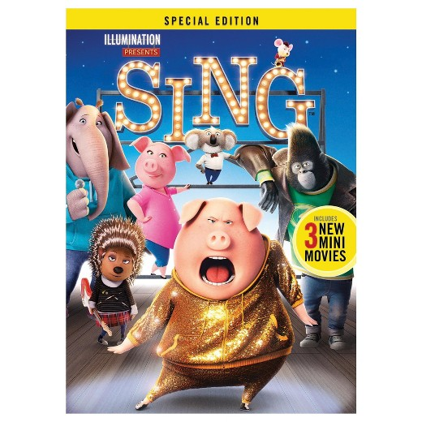**Sing**

Year released: December 21,2016

Director: Garth Jennings, Christophe Lourdelet

Writer: Garth Jennings

In a town modern day

My favorite scene is when Rosita and Gunter were rehearsing. When they were all of Rosita’s little pigs came running in. When they came in they made the papers that showed Rosita and Gunter were to step fly everywhere. Then the little pigs ran every which way.

|  |  |  |
| --- | --- | --- |
| Character Name | Voice Of Character | Picture |
| Buster moon | Matthew McConaughey | Matthew McConaughey in Sing (2016) |
| Miss Crawly | Garth Jennings | Matthew McConaughey, Reese Witherspoon, and Garth Jennings in Sing (2016) |
| Rosita | Reese Witherspoon | Reese Witherspoon in Sing (2016) |
| Ash | Scarleet Johansson | .  Scarlett Johansson in Sing (2016) |

Citations- Paste Links

<https://www.imdb.com/>

<https://www.imdb.com/title/tt3470600/?ref_=rvi_tt>

“Sing.” *IMDb*, IMDb.com,an Amazon Company, 2 Dec. 2016, [www.imdb.com/title/tt3470600/?ref_=rvi_tt](http://www.imdb.com/title/tt3470600/?ref_=rvi_tt).