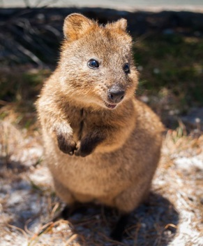 *Australia & Pacific Realm Animal Research*

**My animal: Quokka**

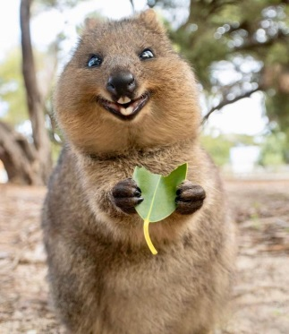**Web site(s):**   
Stevens, Sidney. “10 Of Australia's Cutest Animals.” *MNN*, Mother Nature Network, 31 May 2017, www.mnn.com/earth-matters/animals/photos/9-australias-cutest-animals/land-precious.   
Burrell, Sue. “Quokka.” *The Australian Museum*, 4 Nov. 19AD.australianmuseum.net.au/learn/animals/mammals/quokka/#:~:targetText=Habitat,range%20of%20semi%2Darid%20areas.

Russell, Cale. “Quokka.” *The Animal Facts*, TheAnimalFacts.com, 12 Nov. 2014, xt=Quokkas%20measure%2040-90cm%20(16,5kg%20(5.5-11lb).&targetText=Lifespan%20for%20the%20quokka%20is%205-10https://theanimalfacts.com/mammals/quokka/#:~:targetTe.

[Bere, Jessie, and Trevor Hanke. “Setonix Brachyurus.”](http://bioweb.uwlax.edu/bio203/f2013/hanke_trev/adaptation.htm" \l ":~:targetText=Adaptation,predators%20and%20the%20hot%20sun.)*[UWL Website](http://bioweb.uwlax.edu/bio203/f2013/hanke_trev/adaptation.htm" \l ":~:targetText=Adaptation,predators%20and%20the%20hot%20sun.)*[, Free CSS Templates., Dec. 13AD, bioweb.uwlax.edu/bio203/f2013/hanke_trev/adaptation.htm#:~:targetText=Adaptation,predators%20and%20the%20hot%20sun.](http://bioweb.uwlax.edu/bio203/f2013/hanke_trev/adaptation.htm" \l ":~:targetText=Adaptation,predators%20and%20the%20hot%20sun.)

Smith, P.A. “Quokka Facts: Quokkas: Australian Marsupials.” *Animal Fact Guide*, Animal Fact Guide , 20 Mar. 2018, animalfactguide.com/animal-facts/quokka/#:~:targetText=Quokkas%20are%20herbivores%20who%20primarily,fat%20stored%20in%20their%20tails

**Family, Genus & Species: Family is Macropods and its Genus is Setonix**

**Habitat and location:** They are normally around dense streamside vegetation but they can also be found in shrubland and heath areas.

**Statistics (Size, weight & lifespan): they are 16-35 inches, 5.5-11 pounds, and there lifespan is 5-10 years.**

**Physical adaptations to environment: The Quokka has a light brown fur coat that they use to blend in to the long grass and they stay in the vegetation in the day to hide from the sun.**

**Diet: A Quokka is a Herbivore they eat Native grasses, leaves, stems, fruits, berries, and bark off of trees.**

**Habits: Quokkas can go a long period of time without food because they can live off the fat of their tails.**

**Additional Information: Quokkas are the only members of their Genus Setonix.”** When European explorers first discovered the quokka they believed it was a large rat with brown fur. Rottnest island was even named for this.”

MCj01113560000[1]

**Highlight your most interesting fact. Email sheet & a picture of your animal to Mrs. Snow.**